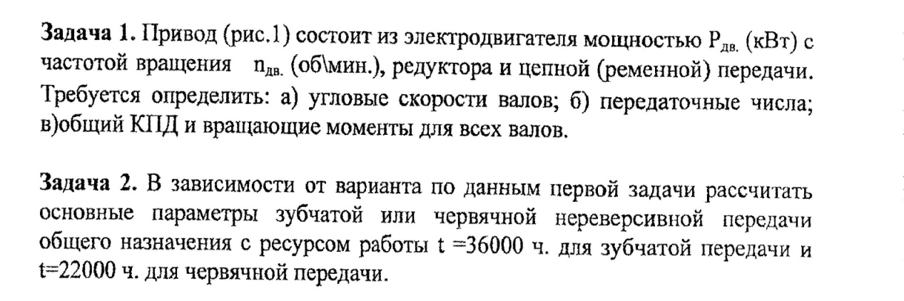

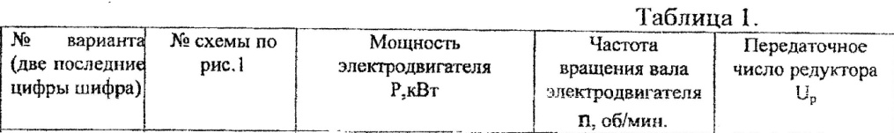

C:\Users\Дмитрий\AppData\Local\Microsoft\Windows\Temporary Internet Files\Content.Word\Scan0002.jpg

